Homework: ggplot Univariate Distribution Graphics

# 1. The Standard Normal Quantile Plot

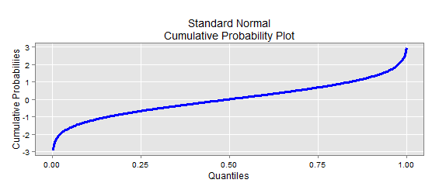

# 2.2 Juxtaposed Density Plots

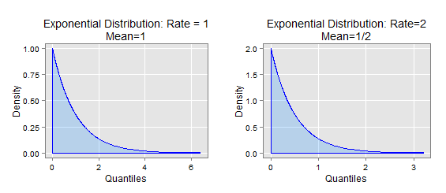

# 3.2 Juxtaposed Density Plots

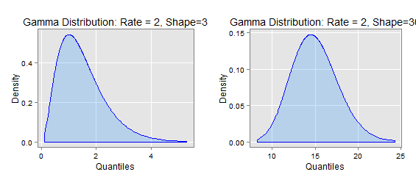

# 4.2 One Eda plot

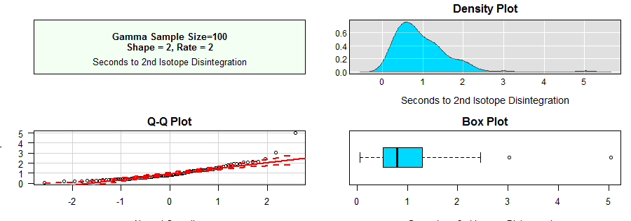

# 6.4 Q-Q Plot with Reference Line

